**ACTIVITIES OF DAILY LIVING (ADLS)**

Activities of daily living (ADLs) are basic tasks that must be accomplished every day for an individual to thrive.

* **Personal hygiene**Bathing, grooming, oral, nail and hair care
* **Continence management**A person’s mental and physical ability to properly use the bathroom
* **Dressing**A person’s ability to select and wear the proper clothes for different occasions
* **Feeding**Whether a person can feed themselves or needs assistance
* **Ambulating**The extent of a person’s ability to change from one position to the other and to walk independently

**Instrumental Activities of Daily living (IADLs)**

* **Companionship and mental support**This is a fundamental and much needed IADL for daily living. It reflects on the help that may be needed to keep a person in a positive frame of mind
* **Transportation and shopping**How much a person can go around or procure their grocery and pharmacy needs without help
* **Preparing meals**Planning and preparing the various aspects of meals, including shopping and storing groceries
* **Managing a person’s household**Cleaning, tidying up, removing trash and clutter, and doing laundry and folding clothes
* **Managing medications**How much help may be needed in getting prescriptions filled, keeping medications up to date and taking meds on time and in the right dosages
* **Communicating with others**Managing the household’s phones and mail and generally making the home hospitable and welcoming for visitors
* **Managing finances**  
  How much assistance a person may need in managing bank balances and check books and paying bills on time

[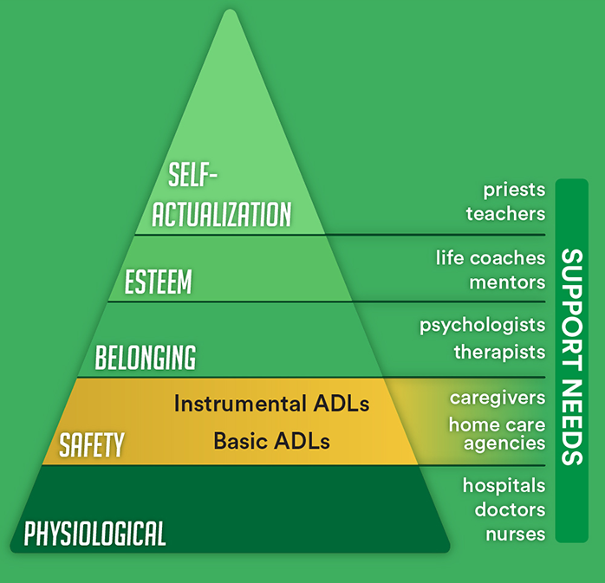](https://media.kindlycare.com/wordpress/uploads/2017/03/ADLs-Infographic-pyramid.png)